Part II: Use Case Description – Scenario

Use Case Name: Quizzes

Actors: Student and Professor

Stakeholders and Needs:

* Must have an appropriate title to differentiate between different quizzes.
* If applicable, must show time limit for quiz.
* If applicable, must show due date and provide a submission option.
* If applicable, show quiz answers/results after submission is entered.
* Notify when quiz is published.

Preconditions:

* Course for which quiz is being viewed should be listed
* Quizzes with appropriate names and due dates should be listed

Post conditions:

* Student should be able to review their answers/feedback or view file submissions
* Student should be able to see grade for quiz

Trigger: Professor publishes a quiz which the student will take and receive a grade upon completion.

Basic Flow:

1. A quiz is published
2. The student is notified
3. The student takes the quiz
4. The student receives grade upon completion

Extensions:

* A button to retake quiz if multiple attempts are allowed
* A button to review previous attempts

Part III: Interaction Design Principles

SAC:

* Simplicity: Canvas is simple and user friendly as a user can access a specific entity under a specific tab. For example, if a student wants to check their grade, they only must select the course they wish to view and select the grade tab.
  + 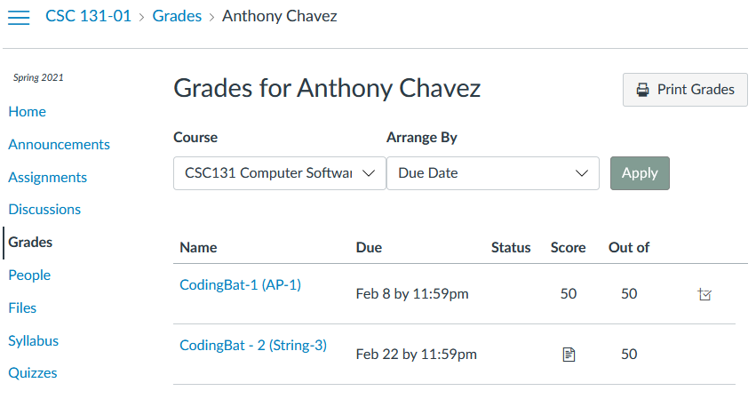
* Accessibility: A user can use any desktop, laptop, or mobile device to interact with the Canvas interface. Canvas also allows the user to toggle features such as High Contrast UI and Underline Links which accommodate people with disabilities.
  + 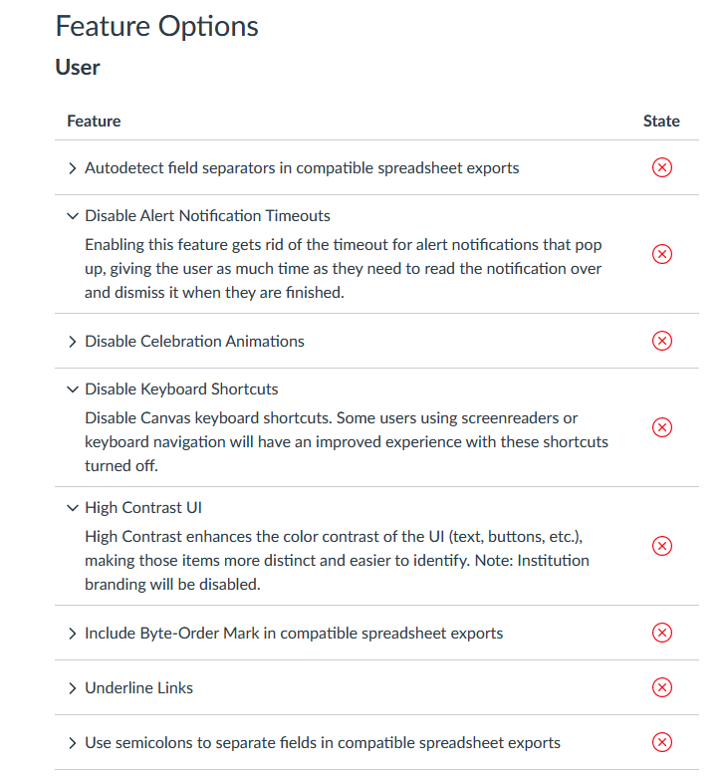
* Consistency: Canvas uses the same tab order as well as grouping everything appropriately across all courses. For example, if a user selects a course, the tabs: Home, Announcements, Assignments, Discussions, Grades, etc. will be the same order as other courses.
  + 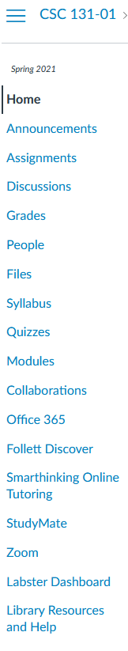 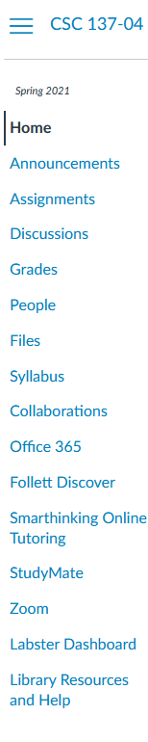

CAP:

* Contrast: One example of contrast in Canvas is the Green text boxes that appear when a student can submit an assignment or add a new discussion topic.
  + 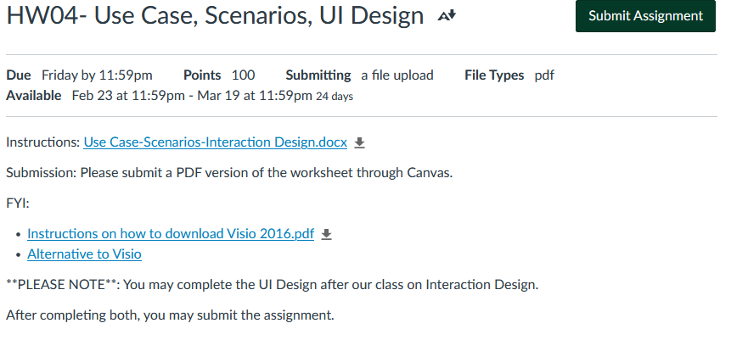
  + 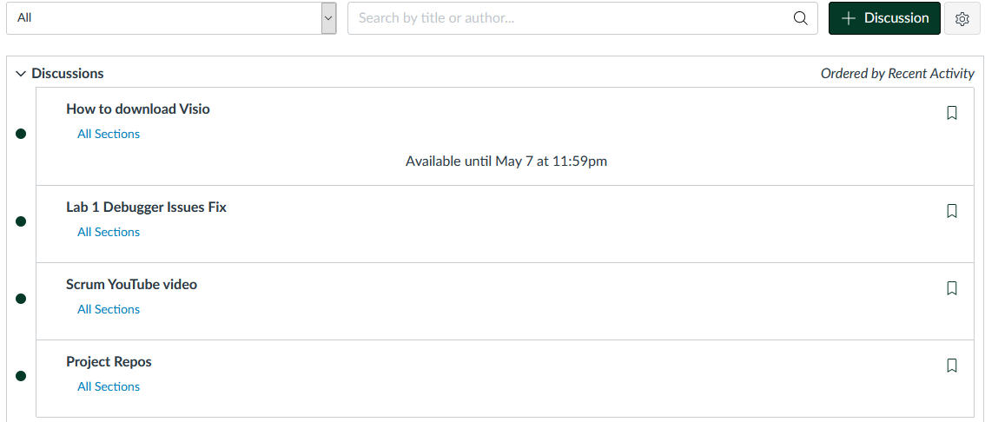
* Alignment: Canvas uses a grid like pattern to display grades where the assignment names, their due dates, and scores are shown in a formal manner.
  + 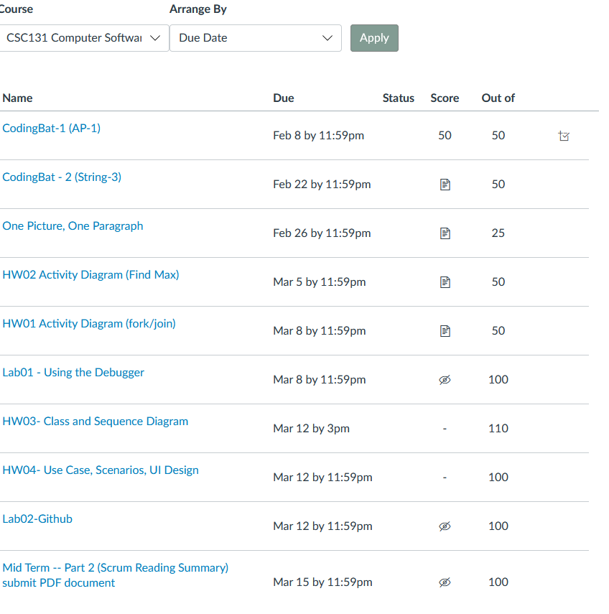
* Proximity: One example shown is Canvas is when a student clicks on the Courses tab, all his or her courses are shown in a pop up tab. Only courses are shown since they belong to the same group.
  + 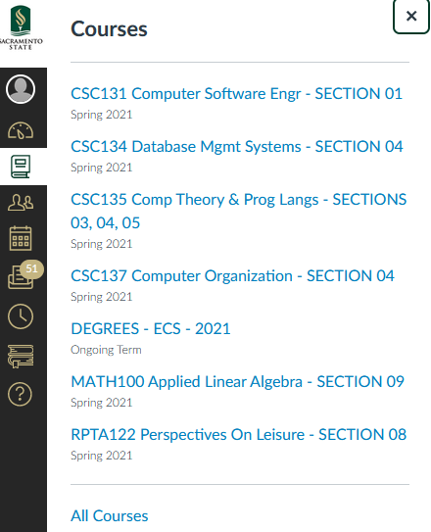

FeVER:

* Feedback: After submitting an assignment, Canvas will have the following message to let the user know the submission was successful, failed, or queued for uploading.
  + 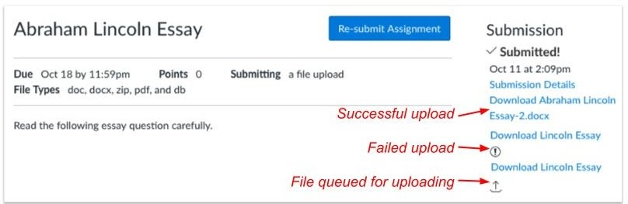
* Visibility: When accessing the files uploaded by another user on Canvas, the user is able to see options such as Download or Alternative formats by clicking the three dots to the right of the file.
  + 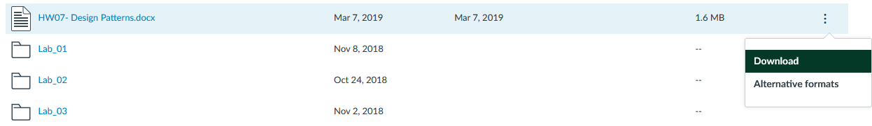
* Error Prevention: One example of error prevention that Canvas has implemented is when a user provides invalid login credentials. Below is an example of an error message when a user enters an invalid username.
  + 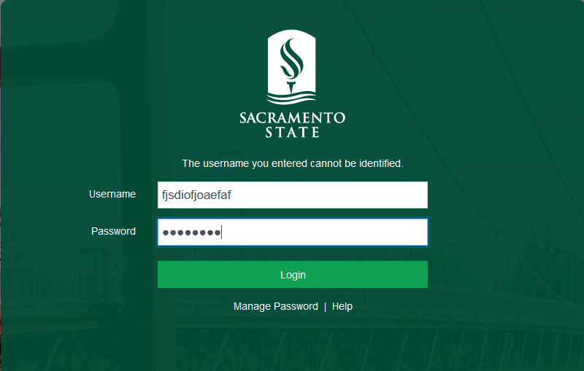
* Recovery: One recovery method that Canvas has implemented is allowing a student to resubmit an assignment before the due date.
  + 